**Human Resource Overview**

(A Power Query-Excel Project)

This document outlines the step-by-step process of creating a dynamic HR dashboard in Excel using Power Query and pivot tables.

**Step 1: Importing Data into Excel**

To begin, we need an HR overview dataset. I used data from the **"Real World Fake Data"** website, which provides excellent datasets for practice.

1. **Import Data**:
   * Open Excel and go to the **Data** tab in the ribbon.
   * Click on **Get Data > From File>From Workbook**, then select the downloaded Excel file.
   * After selecting the file, click **Transform** to open Power Query for data cleaning and transformation.

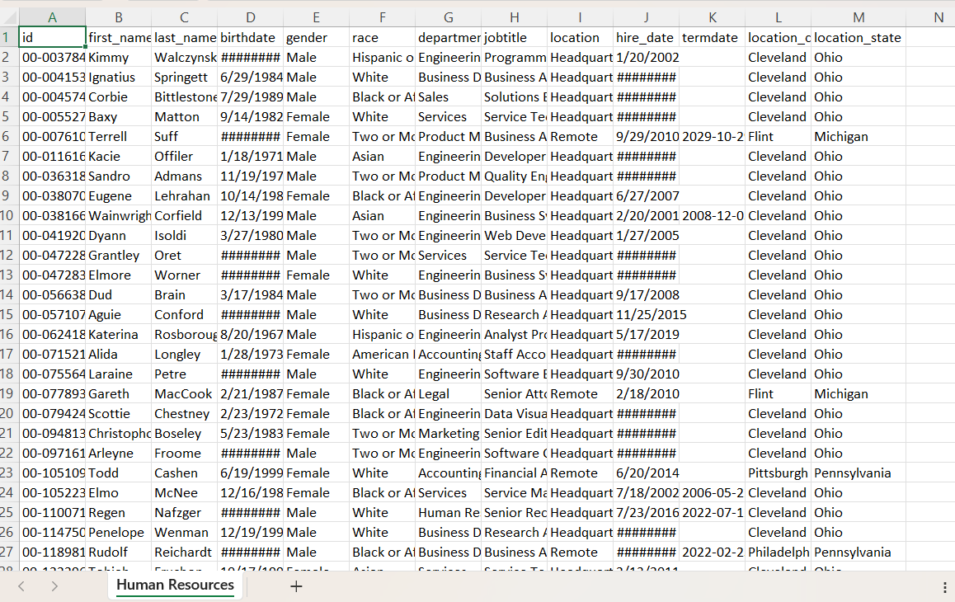

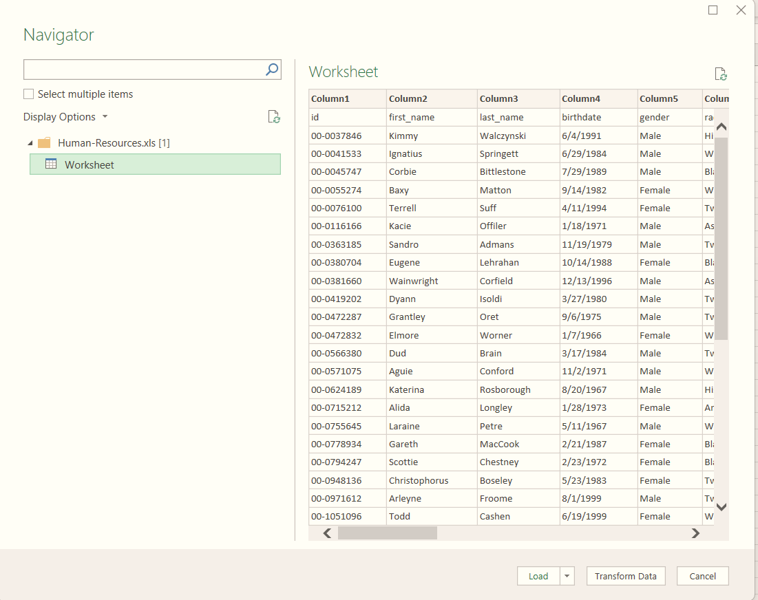

**Step 2: Data Cleaning and Transformation in Power Query**

Once the data is loaded into Power Query, we’ll clean and prepare it for analysis.

1. **Remove Duplicates**:
   * Right-click on the appropriate column(s) and select **Remove Duplicates** to ensure data consistency.
2. **Format Dates**:
   * Change the format of the Hire Date and Birth Date columns:
     + Right-click the column header, select **Change Type > Using Locale**, and set the desired date format.
3. **Calculate Age** **using current data and birthdate column**
   * Navigate to **Add Column > Custom Column** and use this formula:



* Rename the new column to Age.

1. **Calculate Work Experience**:
   * Use the same process to calculate work experience using the Hire Date column and the current date.
2. **Rearrange Columns**:
   * Position the Age and Work Experience columns next to the Birth Date and Hire Date columns, respectively.
3. **Load the Transformed Data**:
   * Go to the **Home** tab in Power Query and click **Close & Load** to send the cleaned and transformed data back to Excel.

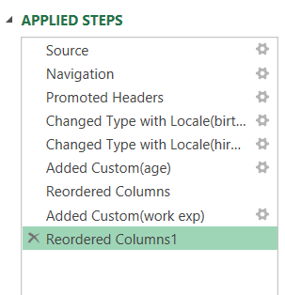

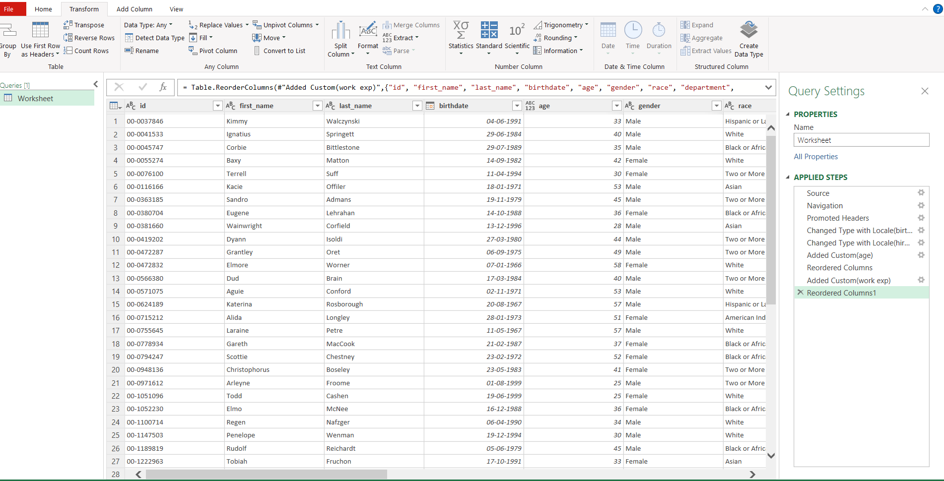

**Step 3: Create KPIs (Key Performance Indicators)**

* + KPI: Count of Employees
    - Insert a pivot table and drag the ID column into the values box.
    - Screenshot: Show the pivot table setup.
  + KPI: Average Age
    - Use the Age column in the pivot table, set it to Average, and format values.
    - Screenshot: Average age pivot table.

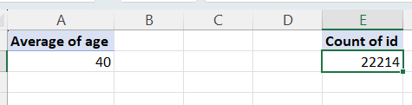

**Step 4: Designing Pivot Tables and Charts**

1. **Line Chart (Hiring Rate by Year)**:
   * Use Hire Date in Rows and ID in Values.

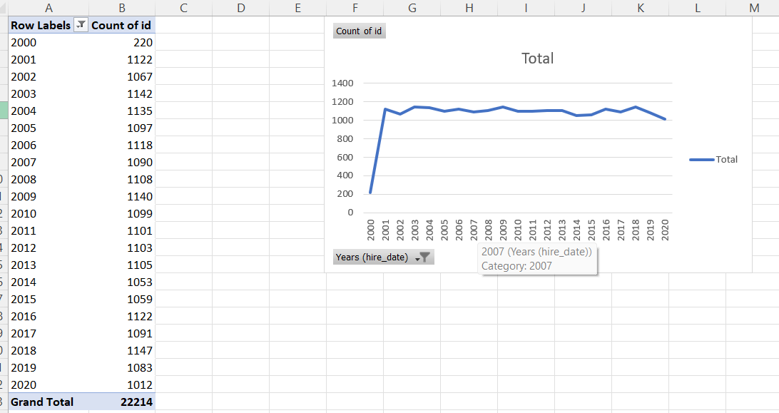

1. **Donut Chart (Gender Distribution)**:
   * Create a pivot table and select the pie chart → Donut.
   * Add data labels with category names.

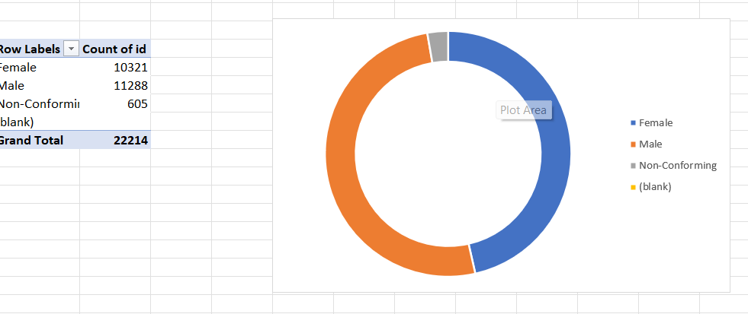

1. **Bar Charts (State, Department, Race)**:
   * Create separate pivot tables for each category and design bar charts.

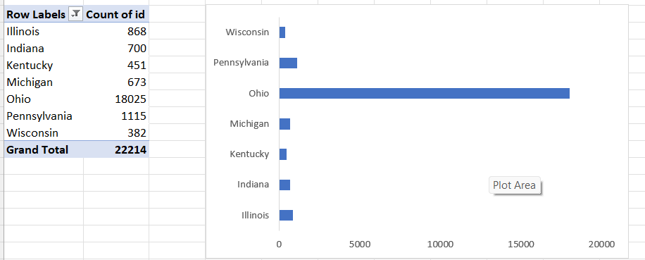

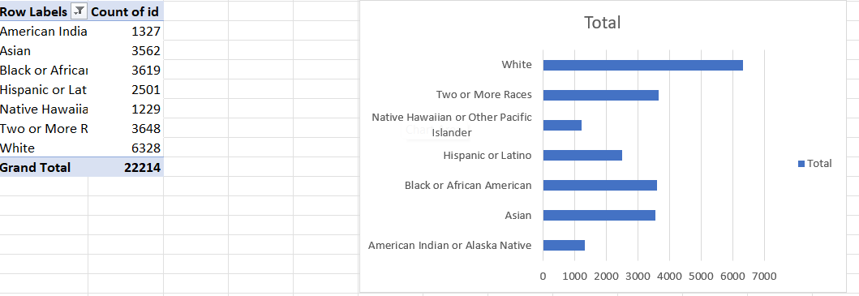

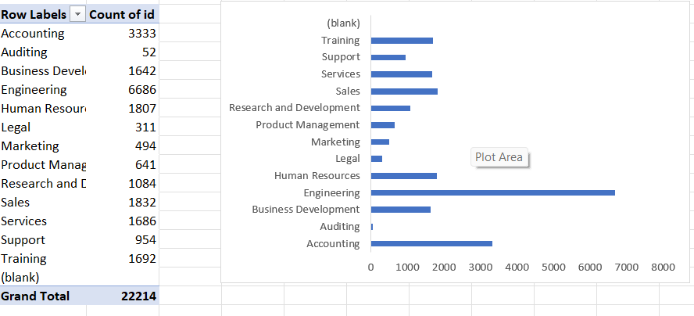

1. **Slicers**
   * Add slicers to filter data (e.g., Gender, State, Department), **click on any pivot** **table>pivot table analyse>Insert Slicer**
   * Use ***Report Connections*** to connect slicers to all related pivot tables.

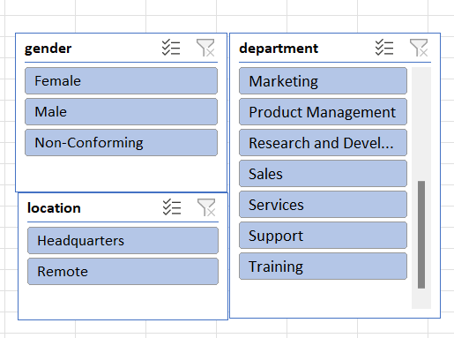

**Step 5: Designing the Dashboard Layout**

1. **Background Design**:
   * Insert a royalty-free background image.
2. **Add Text Boxes**:
   * Use text boxes to create placeholders for **titles, KPIs, charts and slicers.**
   * Align and format text boxes.
3. **Insert Charts and KPIs**:
   * Copy charts and pivot table data to the dashboard.
4. Use formulas in text boxes to link KPIs dynamically.

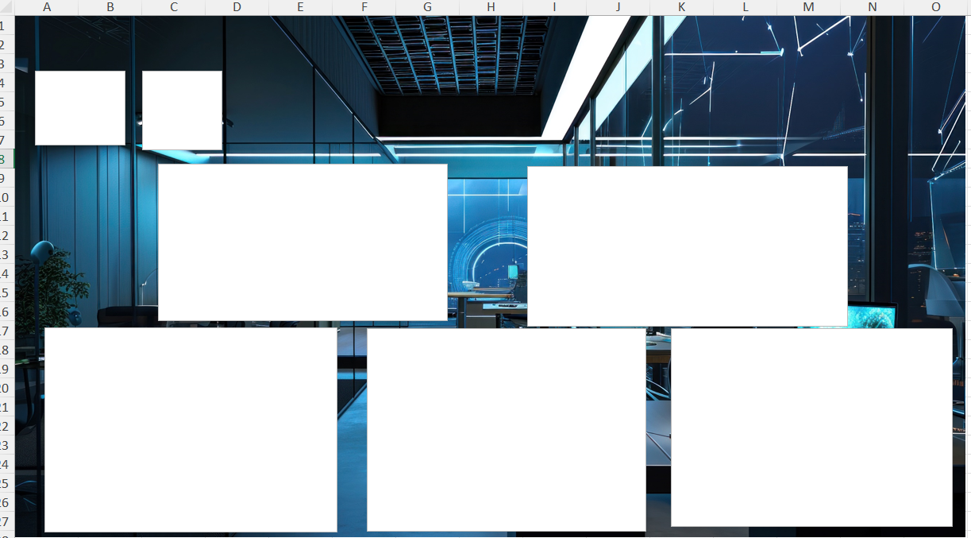

**Final Dashboard**

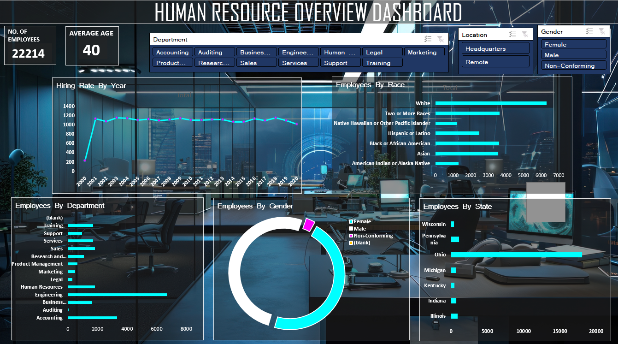

**Insights**

**1.Number of Employees and Average Age:**

* The organization has a total of 22,214 employees, with an average age of 40 years.

**2.Hiring Trends Over Time:**

* The hiring rate peaked in the early 2000s, followed by a consistent hiring pattern in recent years.

**3.Employee Distribution by Race:**

* The majority of employees belong to the White demographic, with significant representation from Asian and Hispanic or Latino groups.
* Smaller groups include African American, Native Hawaiian or Pacific Islander, and Two or More Races.

**4.Employee Distribution by Gender:**

* Male employees form the largest group, followed by female employees.
* A small portion identifies as non-conforming, and some data appears to be blank or missing.

**5.Departmental Breakdown:**

* The largest departments are Engineering, Business, and Human Resources.
* Smaller departments include Auditing, Legal, and Training.

**6.Geographic Distribution:**

* Employees are concentrated in states like Ohio and Illinois, with smaller numbers in Indiana, Michigan, and Kentucky.

**7.Location Breakdown:**

* Employees are divided between Headquarters and Remote locations, showing a mix of traditional and flexible work setups.

**8.Employee Gender and Department Representation:**

* Gender representation varies slightly across departments, with some areas showing a more balanced ratio (e.g., Support Services).